STOCHASTIC PROCESSES
The Mathematics of Randomness in Financial Markets
A Concise Guide from Random Walks to Monte Carlo Simulation
A Level 2 module in the Quantitative Finance Curriculum
Covers: random walks & Brownian motion · Markov property & martingales · geometric Brownian motion · mean reversion & jump-diffusion · Itô's Lemma & SDEs · Black-Scholes · stochastic volatility & interest rate models · Monte Carlo simulation · fat tails and real-world jump risk

Table of Contents
How to Use This Guide
What You Need to Know Before Starting
Understand Before Proceeding
Why It Matters
How This Connects to the Rest of the Curriculum
Glossary of Recurring Terms
Part 1 — Foundations of Randomness
1.1 What Is a Stochastic Process?
1.2 Random Walks and Brownian Motion
1.3 The Markov Property and Martingales
Part 2 — Core Models in Finance
2.1 Geometric Brownian Motion
2.2 Mean Reversion: The Ornstein-Uhlenbeck Process
2.3 Jump-Diffusion Processes
Part 3 — Stochastic Calculus Essentials
3.1 Itô's Lemma
3.2 Stochastic Differential Equations and Simulation
3.3 From SDEs to Black-Scholes
Part 4 — Advanced Models and Monte Carlo
4.1 Stochastic Volatility: The Heston Model
4.2 Interest Rate Models
4.3 Monte Carlo Simulation
Part 5 — Real-World Applications and Pitfalls
5.1 Fat Tails and the Limits of the Normal Distribution
5.2 The 2010 Flash Crash and Jump Risk
5.3 Model Risk, Calibration, and Regime Change
Practical Exercise
Common Beginner Mistakes
Advanced Extensions
Professional Applications
Where to Go Next

How to Use This Guide
This guide introduces stochastic processes: mathematical models of quantities that evolve randomly over time. Nearly every pricing formula, risk model, and simulation used elsewhere in this curriculum — Black-Scholes, Monte Carlo value-at-risk, the Ornstein-Uhlenbeck spreads traded in Statistical Arbitrage — is a specific stochastic process wearing a financial costume. This guide moves from the basic building blocks to the models and simulation techniques built from them, favoring brevity over exhaustive detail. Read start to finish, or jump to any part using the Table of Contents.

What You Need to Know Before Starting
- Basic probability and statistics — mean, variance, and the normal distribution.
- Basic calculus — derivatives and the idea of an infinitesimal change.
- Comfort with formulas expressed in continuous time — no prior stochastic calculus is assumed.

Understand Before Proceeding
Prerequisite gate — Every model in this guide makes simplifying assumptions — constant volatility, continuous prices, normally distributed shocks — that real markets violate to varying degrees. A stochastic process is a model of randomness, not randomness itself, and the gap between the two is exactly where model risk lives. Part 5 exists specifically to show what happens when that gap is ignored.

Why It Matters
Stochastic processes are the common mathematical language beneath option pricing, risk simulation, interest rate modeling, and algorithmic trading signal design. Understanding a handful of core processes — the random walk, Brownian motion, mean reversion, and jump-diffusion — lets you recognize the same underlying structure across dozens of seemingly unrelated financial models, rather than memorizing each one separately.

How This Connects to the Rest of the Curriculum
- Options and Futures — Black-Scholes, covered in full there, is derived directly from the geometric Brownian motion and Itô's Lemma developed here in Parts 2–3.
- Statistical Arbitrage — The Ornstein-Uhlenbeck process used to model a tradeable spread is covered here in Part 2.2 from first principles.
- FX & Crypto — Interest rate and volatility models built from the SDEs in Part 3 price the forwards, options, and derivatives covered in those modules.

Glossary of Recurring Terms
Stochastic process — A collection of random variables indexed by time, representing a quantity that evolves randomly.
Brownian motion (Wiener process) — The continuous-time limit of a random walk: a process with independent, normally distributed increments and continuous (but nowhere smooth) paths.
Markov property — The property that a process's future depends only on its current value, not on the path taken to get there.
Martingale — A process whose expected future value, given everything known today, equals its current value — a mathematical "fair game."
Geometric Brownian motion (GBM) — A process in which the logarithm of the value follows Brownian motion with drift, producing continuously compounded, lognormally distributed returns.
Mean reversion — The tendency of a process to drift back toward a long-run average level rather than wandering indefinitely.
Jump-diffusion — A process combining continuous, Brownian-driven movement with occasional discontinuous jumps.
Itô's Lemma — The stochastic calculus rule for finding the dynamics of a function of a stochastic process, the direct analogue of the chain rule in ordinary calculus.
Stochastic differential equation (SDE) — An equation describing a process's instantaneous drift and random shock, of the form dX = drift·dt + volatility·dW.
Euler-Maruyama method — The simplest numerical scheme for simulating an SDE, by discretizing time into small steps.
Stochastic volatility — A model in which volatility is itself a random process rather than a constant, as in the Heston model.
Monte Carlo simulation — Estimating a quantity by simulating many random paths of the underlying process and averaging the outcome.
Fat tails — The tendency of real financial returns to produce extreme outcomes far more often than a normal distribution predicts.
Model risk — The risk that a model's assumptions are wrong or poorly calibrated, leading to systematically mispriced or mismanaged positions.

Part 1 — Foundations of Randomness
Part 1 introduces the basic vocabulary: what a stochastic process is, the random walk and its continuous-time limit, and two properties — Markov and martingale — that recur throughout the rest of this guide.

1.1 What Is a Stochastic Process?
A stochastic process is a sequence of random variables indexed by time — a rule for how a quantity evolves under uncertainty, rather than a single predicted path. A stock price, an interest rate, and a spread between two related securities are all naturally modeled this way: at each moment, the next value is drawn from a probability distribution rather than known in advance.
Two broad categories matter for this guide: discrete-time processes (a value updates at fixed intervals, like daily closing prices) and continuous-time processes (a value evolves at every instant, the natural setting for options pricing). This guide moves from the discrete random walk to its continuous-time limit, Brownian motion, in the next section.

1.2 Random Walks and Brownian Motion
A random walk takes an independent, equally likely step up or down at each time increment. As the time step shrinks toward zero while the number of steps grows accordingly, the random walk converges to Brownian motion (or a Wiener process): a continuous-time process with independent, normally distributed increments.
$$W\left(t+∆t\right)-W\left(t\right)\sim Normal\left(0, ∆t\right)$$
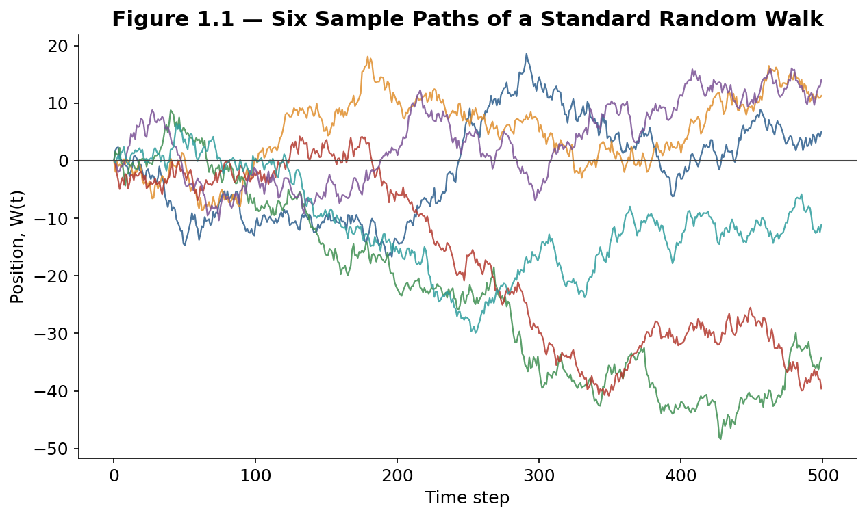
Figure 1.1 — Six independent random walks starting from the same point: each is equally likely to have gone up or down at every step, yet they fan out into very different-looking paths — the same variance-accumulates-with-time logic that governs Brownian motion.
Tip — Brownian motion paths are continuous but nowhere differentiable — they have no well-defined slope at any point, however finely you zoom in. This single fact is why ordinary calculus cannot be applied directly to stochastic processes, and why Itô's Lemma in Part 3.1 is needed instead.

1.3 The Markov Property and Martingales
A process has the Markov property if its future depends only on its current value, not on the history of how it got there — "memorylessness." Brownian motion and most of the models in this guide are Markov processes, which is what makes them tractable: pricing and forecasting only need today's value, not the entire past.
A process is a martingale if its expected future value, given all information available today, equals its current value — a mathematical "fair game" with no predictable drift. This concept underlies risk-neutral option pricing directly: under the right choice of measure, a discounted asset price must be a martingale, or an arbitrage opportunity would exist.

Part 2 — Core Models in Finance
Part 2 covers the three stochastic processes that appear most often in financial modeling: geometric Brownian motion for prices, the Ornstein-Uhlenbeck process for mean-reverting quantities, and jump-diffusion for markets that move in sudden jolts as well as continuous drift.

2.1 Geometric Brownian Motion
Asset prices cannot go negative, so plain Brownian motion is a poor model for a price itself. Geometric Brownian motion (GBM) instead applies Brownian motion to the logarithm of price, guaranteeing positivity and producing the lognormal return distribution underlying Black-Scholes:
$$dS=μS*dt+σS*dW$$
Here μ is the drift (expected return) and σ is volatility. Because the shocks are proportional to the current price level, a $100 stock and a $10 stock with the same σ experience the same percentage volatility, not the same dollar volatility.
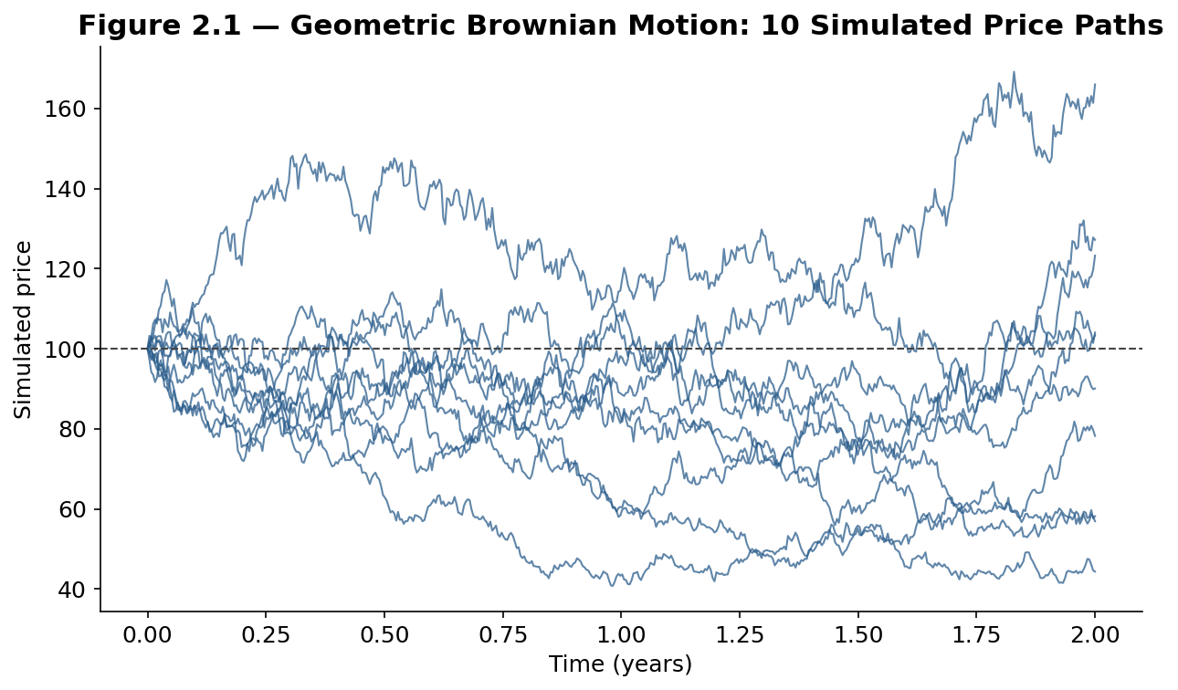
Figure 2.1 — Ten simulated GBM paths from the same starting price: returns are symmetric in log terms, but the price itself can rise much further than it can fall, producing the right-skewed spread of outcomes visible here.

2.2 Mean Reversion: The Ornstein-Uhlenbeck Process
Not every financial quantity trends indefinitely. Interest rates, volatility, and the spread between two cointegrated securities (the subject of the Statistical Arbitrage module) tend to drift back toward a long-run average instead. The Ornstein-Uhlenbeck (OU) process is the standard model for this behavior:
$$dX_{t}=θ\left(μ-X_{t}\right) dt+σ dW_{t}$$
θ controls the speed of reversion, μ is the long-run mean, and σ is volatility. Larger θ pulls the process back toward μ faster, producing a tighter, choppier path; smaller θ allows longer excursions away from the mean before reverting.
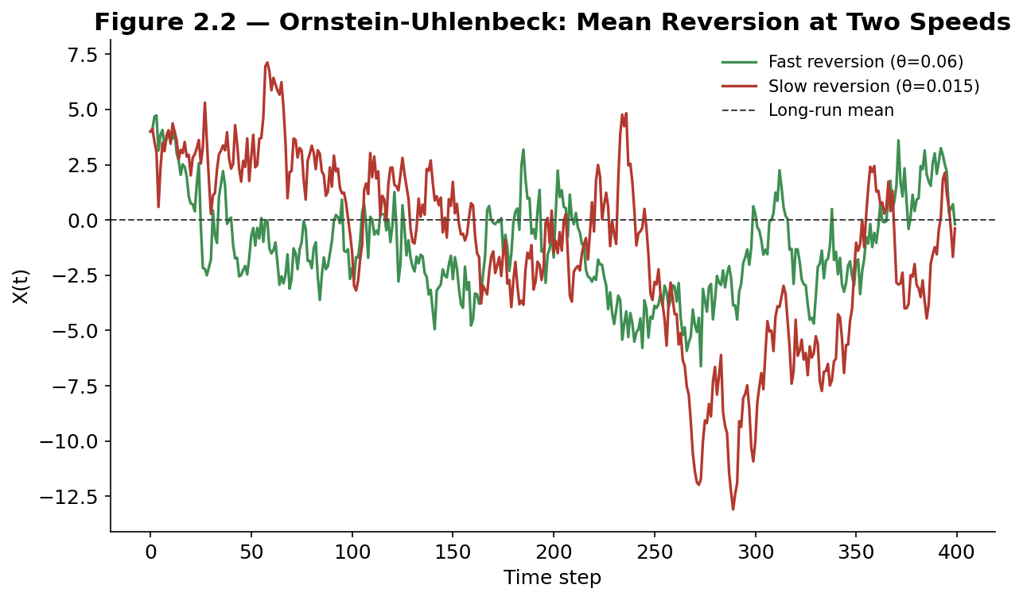
Figure 2.2 — Fast mean reversion (large θ) stays tightly clustered near its long-run mean; slow mean reversion (small θ) wanders much further before pulling back, behaving more like a random walk in the short run.

2.3 Jump-Diffusion Processes
GBM assumes prices move continuously, with no sudden gaps — a poor description of real markets around earnings surprises, central bank announcements, or crises. Jump-diffusion models (most famously Merton's 1976 model) add a separate jump component, typically a Poisson process governing when jumps occur, combined with a distribution governing their size:
$$\frac{dS_{t}}{S_{t}}=μ dt+σ dW_{t}+dJ_{t}$$
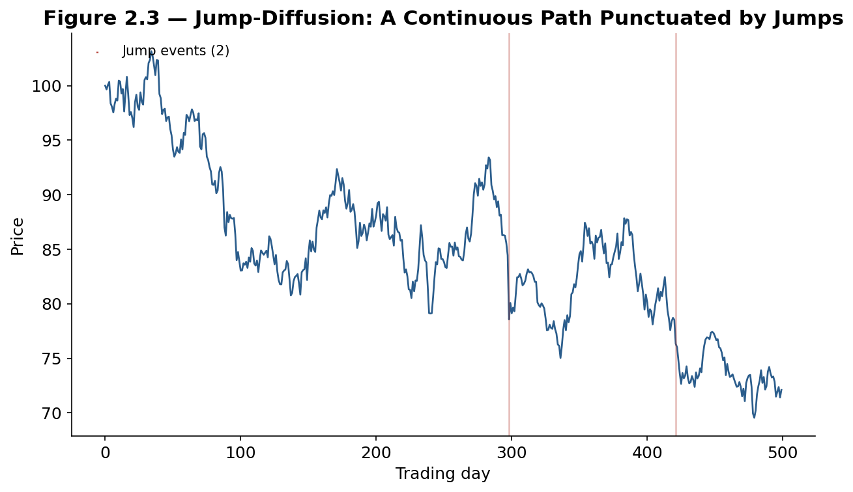
Figure 2.3 — A simulated jump-diffusion path: ordinary GBM-like drift and diffusion between jump events, punctuated by two sudden, discontinuous drops that no continuous diffusion process alone can produce.

Part 3 — Stochastic Calculus Essentials
Part 3 covers the minimum stochastic calculus needed to go from a process's defining equation to a pricing formula: Itô's Lemma, the general SDE framework, and how both combine to derive Black-Scholes.

3.1 Itô's Lemma
Because Brownian motion is nowhere differentiable (Part 1.2), the ordinary chain rule does not apply to a function of a stochastic process. Itô's Lemma is the corrected version, with an extra term reflecting the process's variance:
$$dF=\left(\frac{∂F}{∂t}+μ\frac{∂F}{∂S}+\frac{1}{2}σ^{2}S^{2}\frac{∂^{2}F}{∂S^{2}}\right)dt+σS\frac{∂F}{∂S} dW$$
That extra second-derivative term — absent from ordinary calculus — is the mathematical fingerprint of randomness, and it is exactly what produces the famous −½σ² adjustment between a GBM process's arithmetic drift and its logarithm's drift.

3.2 Stochastic Differential Equations and Simulation
Every process in Part 2 is written as a stochastic differential equation (SDE): a drift term plus a random shock term, dX = a(X,t) dt + b(X,t) dW. Most SDEs used in practice have no closed-form solution and must be simulated by discretizing time into small steps — the Euler-Maruyama method being the simplest approach, directly approximating the SDE step by step:
$$X_{t+Δt}≈X_{t}+a\left(X_{t} , t\right)Δt+b\left(X_{t} , t\right)\sqrt{Δt} Z where Z∼N\left(0 , 1\right)$$
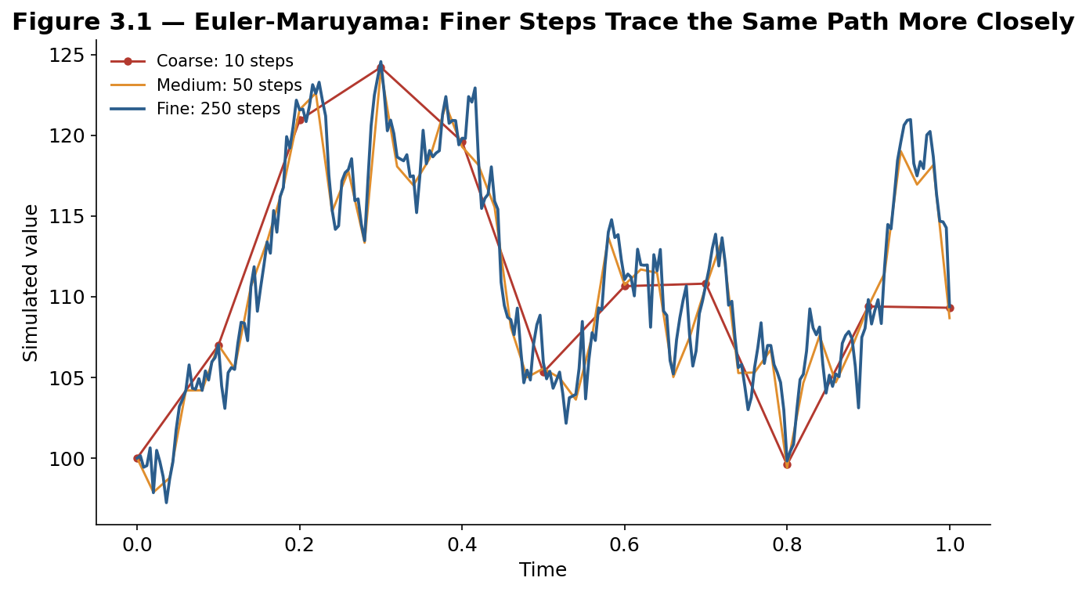
Figure 3.1 — The same underlying random path, simulated at three different step sizes: 10 coarse steps trace the overall shape but miss the detail; 250 fine steps converge closely to the true continuous path.

3.3 From SDEs to Black-Scholes
Combining GBM's SDE (Part 2.1) with Itô's Lemma applied to an option's value function, then imposing a no-arbitrage condition, yields the Black-Scholes partial differential equation — the same model covered from a trading perspective in the Options and Futures module:
$$\frac{∂V}{∂t}+\frac{1}{2}σ^{2}S^{2}\frac{∂^{2}V}{∂S^{2}}+rS\frac{∂V}{∂S}-rV=0$$
Every input to that equation — σ, r, the payoff V — traces back directly to the GBM assumption and Itô's Lemma covered in this part; Black-Scholes is not a separate model so much as a direct consequence of the two.

Part 4 — Advanced Models and Monte Carlo
Part 4 extends the core toolkit to models that relax GBM's constant-volatility assumption, covers the standard family of interest rate models, and introduces Monte Carlo simulation as the general-purpose tool used when no closed-form pricing formula exists.

4.1 Stochastic Volatility: The Heston Model
Real implied volatility is not constant — it varies by strike (the skew covered in the Options and Futures module) and over time (volatility clustering: calm periods and turbulent periods each tend to persist). The Heston model addresses this by making volatility itself a mean-reverting stochastic process, correlated with the underlying's own returns:
$$dS_{t}=μS_{t} dt+\sqrt{v_{t}} S_{t} dW_{1,t} dv_{t}=κ\left(θ-v_{t}\right) dt+ξ\sqrt{v_{t}} dW_{2,t}$$
v is instantaneous variance, mean-reverting to a long-run level θ at speed κ; the correlation between dW₁ and dW₂ is typically negative for equities, capturing the empirical tendency for volatility to rise as prices fall (the "leverage effect").

4.2 Interest Rate Models
Interest rates need their own dedicated models, since GBM's assumption of proportional shocks and unbounded growth fits a stock price better than a rate. The Vasicek model applies an OU process directly to the short rate (allowing rates to go negative); the CIR (Cox-Ingersoll-Ross) model adds a √r term that keeps rates non-negative; the Hull-White model extends Vasicek with a time-varying mean level, fitted to match today's observed yield curve exactly.
Model | Base structure | Key feature
Vasicek | Ornstein-Uhlenbeck | Simple, closed-form; rates can go negative
CIR | OU with √r volatility | Rates stay non-negative
Hull-White | Time-varying Vasicek | Fits today's full yield curve exactly

4.3 Monte Carlo Simulation
When a model has no closed-form pricing formula — a path-dependent option, a Heston-model price, a portfolio-level risk estimate — Monte Carlo simulation provides a general solution: simulate thousands of random paths using Euler-Maruyama (Part 3.2), evaluate the outcome of interest on each, and average.
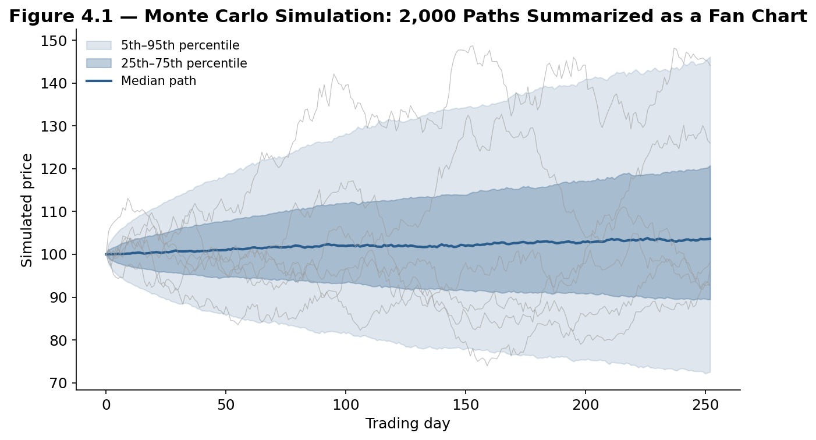
Figure 4.1 — 2,000 simulated GBM paths summarized as a fan chart: the median path stays roughly flat while the spread of outcomes widens with the square root of time, exactly as Brownian motion predicts.
Worked example — To price a European call, simulate the terminal price under the risk-neutral drift across many paths, compute max(S_T − K, 0) on each, average the results, and discount back to today at the risk-free rate. With enough simulated paths, this average converges to the same price Black-Scholes gives in closed form.

Part 5 — Real-World Applications and Pitfalls
Part 5 closes with where these models meet real markets: the well-documented gap between the normal distribution and actual returns, a real-world jump event no diffusion model anticipates, and the broader risk of relying on any single calibrated model.

5.1 Fat Tails and the Limits of the Normal Distribution
GBM assumes normally distributed log-returns, but real financial returns are consistently fat-tailed: extreme moves occur far more often than a normal distribution predicts. A move of 5 or more standard deviations, which a normal distribution says should happen once in thousands of years, has occurred multiple times in major markets within recent decades.
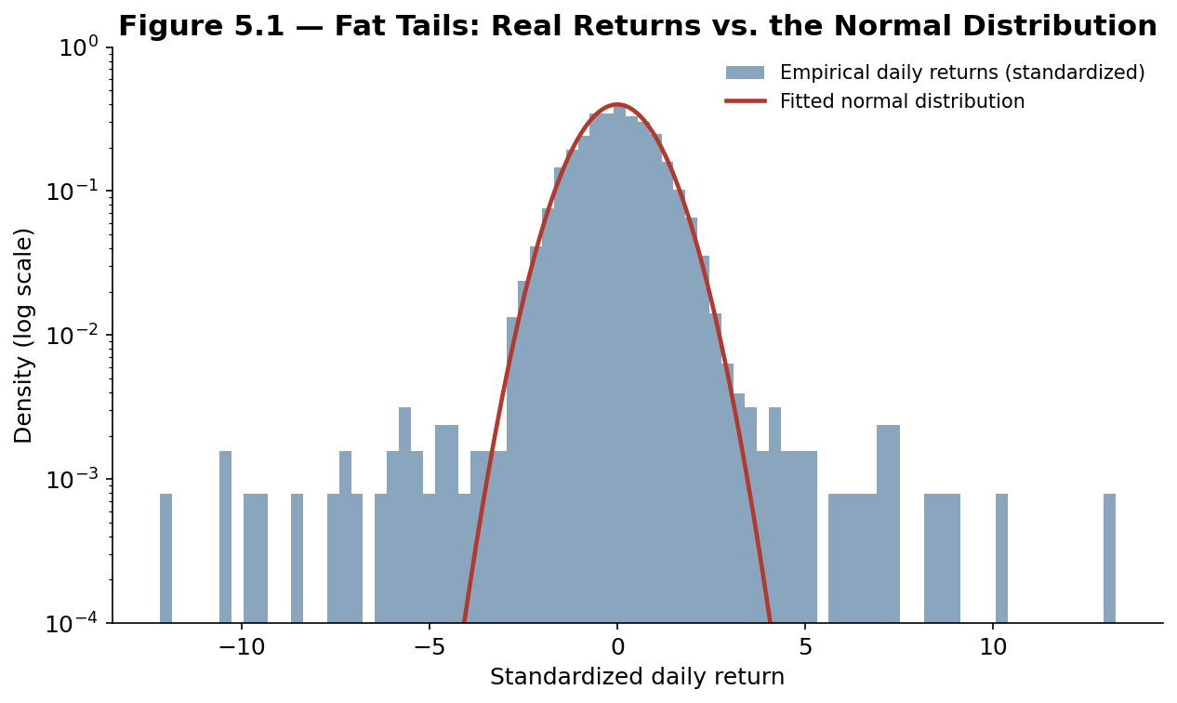
Figure 5.1 — On a log scale, the gap between real returns and the fitted normal distribution is stark: the empirical histogram sits visibly above the normal curve far out in both tails, where the normal model says almost nothing should happen.
Common mistake — Using a GBM-based value-at-risk model and treating its tail estimate as a reliable worst case. Because GBM underweights extreme moves systematically, a model calibrated to it will understate the true probability and size of a severe loss — a central lesson behind Long-Term Capital Management's 1998 collapse, which relied on historical correlations and near-normal assumptions that broke down simultaneously under stress.

5.2 The 2010 Flash Crash and Jump Risk
On 6 May 2010, major US equity indices fell around 9% and recovered within roughly 20 minutes, in what became known as the Flash Crash — later attributed by regulators to a large automated sell order interacting with high-frequency trading algorithms and a temporary evaporation of liquidity. No diffusion-only model (GBM, Heston) can produce a move like this; only a jump-diffusion process (Part 2.3), with a jump component calibrated to rare but severe events, comes close to describing it.
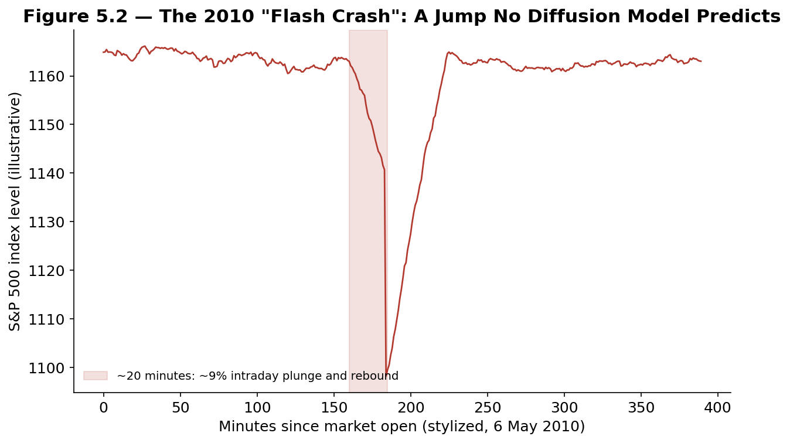
Figure 5.2 — A stylized illustration of 6 May 2010: a sudden intraday jump and rapid reversal, occurring on a timescale far shorter than any daily-return model is built to capture.

5.3 Model Risk, Calibration, and Regime Change
Every model in this guide is calibrated to historical data, and every calibration implicitly assumes the future will resemble the recent past closely enough for the fitted parameters to still apply. A jump intensity, mean-reversion speed, or volatility-of-volatility estimated over a calm period can be badly wrong heading into a regime change — and because most of these models are widely used across the industry simultaneously, a shared blind spot in one popular model's assumptions can itself become a source of correlated risk when many participants are relying on it at once.
Tip — Treat every stochastic model as a simplification chosen for tractability, not a claim about how markets truly work. Stress-test any pricing or risk result against a jump scenario, a volatility regime shift, and a correlation breakdown before relying on it, rather than trusting the calibrated model's own confidence interval alone.

Practical Exercise
Simulate 1,000 GBM paths for a hypothetical stock (choose your own μ, σ, and starting price) using Euler-Maruyama. Compute the terminal-price distribution and compare its mean and standard deviation to the closed-form lognormal formulas. Then repeat with a small jump component added, and compare how the tails of the terminal distribution change.
# Skeleton for the practical exercise

def simulate_gbm(S0, mu, sigma, T, n_steps, n_paths):
dt = T / n_steps
Z = np.random.normal(size=(n_paths, n_steps))
log_ret = (mu - 0.5*sigma**2)*dt + sigma*np.sqrt(dt)*Z
log_paths = np.cumsum(log_ret, axis=1)
return S0 * np.exp(log_paths)

def add_jumps(paths, jump_prob, jump_mean, jump_std):
jumps = np.random.rand(*paths.shape) < jump_prob
jump_sizes = np.random.normal(jump_mean, jump_std, paths.shape)
return paths * np.exp(np.cumsum(jumps * jump_sizes, axis=1))

# Evaluate: terminal mean/std vs. closed-form lognormal formulas,
# and how adding jumps changes the shape of the terminal distribution.

Common Beginner Mistakes
- Applying ordinary calculus to a stochastic process — forgetting the extra Itô term that makes stochastic calculus different from the calculus of smooth functions.
- Treating a calibrated model as ground truth — rather than a simplification with known blind spots.
- Ignoring fat tails — sizing risk from a normal-distribution model without stress-testing for larger, more frequent extreme moves than the model predicts.
- Confusing a Markov model with a memoryless market — the model assumption is a simplification, not a claim that real markets have literally no memory of trends or regimes.

Advanced Extensions
- Lévy processes — a broader family of jump processes generalizing both Brownian motion and Poisson jumps.
- Rough volatility models — recent models suggesting volatility itself behaves more erratically than standard diffusions like Heston assume.
- Filtering and particle methods — estimating a hidden stochastic process (like unobserved volatility) from noisy observed data in real time.

Professional Applications
- Derivatives pricing desks — implement the SDE and Monte Carlo machinery from Parts 3–4 to price and hedge options books daily.
- Risk management teams — run Monte Carlo simulations for value-at-risk and stress testing, informed by the fat-tail and jump-risk lessons in Part 5.
- Quantitative researchers — calibrate stochastic volatility and interest rate models to market data as a core, ongoing part of the job.

Where to Go Next
This guide covered stochastic processes from random walks through Itô's Lemma, the core financial models, Monte Carlo simulation, and the real-world limits of each. The Options and Futures module applies the Black-Scholes result derived here in Part 3.3 directly to trading strategy; the Statistical Arbitrage module applies the Ornstein-Uhlenbeck process from Part 2.2 to tradeable spreads; and the Risk Metrics module builds on Part 4.3's Monte Carlo framework for portfolio-level risk measurement.

